**A1Wd Superimposing two sets of data onto one graph**

In certain circumstances, we may wish to combine different data sets onto the same Excel graph.

**Example**

A market researcher has collected a set of data that measures the distance travelled by 8 sales men. The market researcher has calculated the average and standard deviation (concepts to be covered in the next chapter) and requires a graph of mileage travelled against ID and the two error measurements provided in Table 1.

|  |  |  |  |
| --- | --- | --- | --- |
| ID | Mileage | Average + error | Average - error |
| 1 | 220 | 239 | 208 |
| 2 | 210 | 239 | 208 |
| 3 | 230 | 239 | 208 |
| 4 | 200 | 239 | 208 |
| 5 | 250 | 239 | 208 |
| 6 | 238 | 239 | 208 |
| 7 | 219 | 239 | 208 |
| 8 | 220 | 239 | 208 |
| Average = | 223.38 |  |  |
| Standard deviation = | 15.74 |  |  |

Table 1

**Excel solution**

Step 1 Input data series

Highlight all three columns (including labels)

Mileage: Cells B4:B12

Average + error: Cells C4:C12

Average – error: Cells D4:D12

(include data labels)

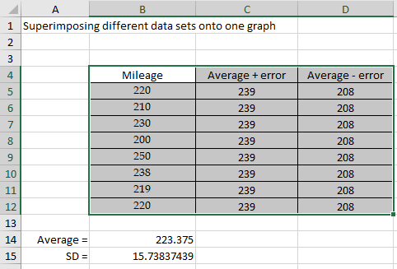

Figure 1

Step 2 Select Insert > Column > choose first option.

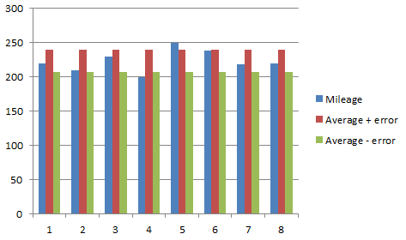

Figure 2

Step 3 Edit the chart

From Figure 2, we note that we have three bars per ID. Edit the chart to include a chart title, axes titles, and remove horizontal grid lines to give the chart illustrated in Figure 3.

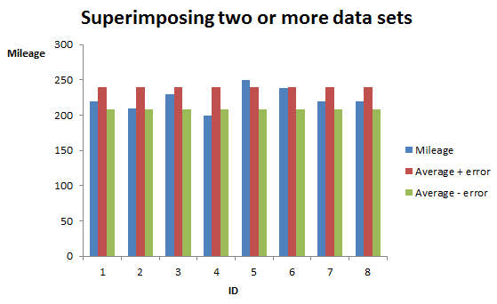

Figure 3

Step 4 Further modification of the chart by changing the bars representing the error term (average - error, average + error) to be horizontal dashed lines rather than vertical bars. Select average – error bar (this will select all the average – error bars for each ID). Right-click on average – error bar > Select Change Series Chart Type > Select Line and click OK. Repeat for average + error bars. The final chart is illustrated in Figure 4.

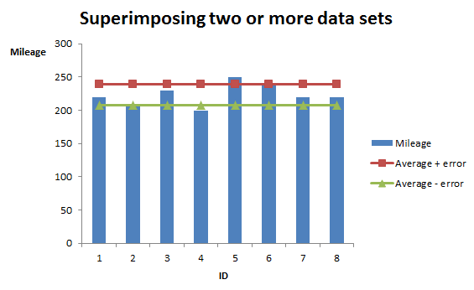

Figure 4

### Check your understanding

X1 Table 2 represents the 2013-2015 quarterly sales for a new chocolate bar.

|  |  |  |  |
| --- | --- | --- | --- |
|  | Year | | |
| Quarter | 2015 | 2016 | 2017 |
| Q1 | 22000 | 24000 | 25000 |
| Q2 | 25000 | 27000 | 27000 |
| Q3 | 21000 | 22000 | 22000 |
| Q4 | 28000 | 30000 | 31000 |

Table 2

(a) Create a bar chart to represent this data.

(b) Comment on how the sales change per quarter for each year.